

FED
Dr Gopi Krishna
B. Akshaya
2520040084
ECE
1

Case Study Topic: File Indexing System

Work Done Summary:
In this case study, we implemented a file indexing system using Binary Search Trees (BST) and self-balancing AVL
Trees to manage hierarchical file metadata efficiently. The BST stores file names in lexicographic order to support
fast search operations. However, for skewed insertions such as alphabetically sorted filenames, the BST degrades to
O(n) performance. The AVL Tree addresses this by automatically rebalancing through LL, RR, LR, and RL
rotations, guaranteeing O (log n) for all operations regardless of input order.
We inserted 10 file records into both structures, observed rotation events in the AVL Tree, and confirmed that
in-order traversal produces a correctly sorted filename index. The AVL Tree maintained a balance factor of -1, 0,
or +1 at every node throughout all insertions and deletions.

Implementation Details:
- Implemented BST insert, delete, and search using recursive traversal.
- Extended the BST to an AVL Tree by tracking node heights and computing balance factors after every insertion.
- Applied LL, RR, LR, and RL rotations whenever the absolute balance factor exceeded 1.
- Inserted 10 file-name keys: alpha.txt, beta.log, gamma. CFG, delta.dat, epsilon. bin, zeta.xml, eta. Json, theta.csv, iota. SQL, kappa.md.
- Compared search performance: BST worst-case O(n) vs AVL guaranteed O (log n).
- Validated in-order traversal to confirm sorted filename index output.

Result / Output:
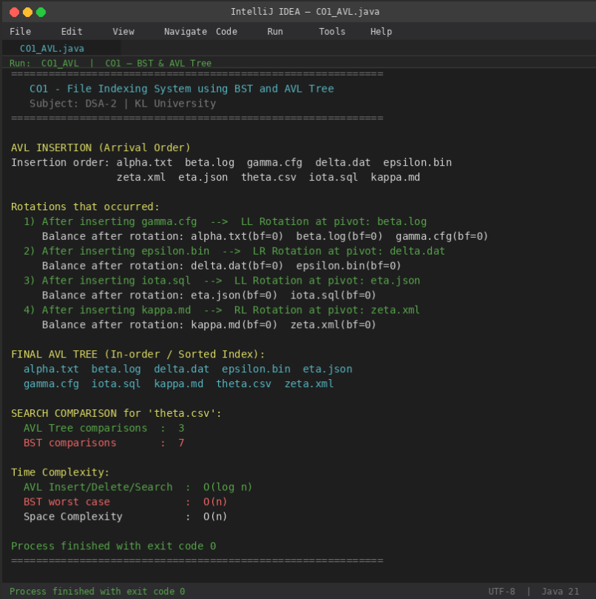

The AVL Tree reduced search comparisons from 7 (BST) to 3 (AVL) for the same key. In-order traversal produces a
perfectly sorted filename index confirming correct BST property is maintained after every rotation.

Time Complexity:
- BST Insert/Search (worst case): O(n) — degrades on sorted input
- AVL Insert/Delete/Search: O (log n) — guaranteed by height balancing
- Space Complexity: O(n)
- AVL Tree outperforms plain BST for sorted or nearly-sorted file-name inputs, making it ideal for file system indexing.

GitHub Link: https://github.com/bagiliakshaya1997-svg/DSA--2

Student Signature | Faculty Signature

